Internship Manual

ABI 4537: Internship in
Airline Business
B.A. degree in Airline Business

College of Hospitality Industry Management,
Suan Sunandha Rajabhat University
Bangkok, Thailand.

Table of Contents
Page
Chapter 1 Introduction 4
Objectives 5
Conditions 5
Scope of duty 7
ABI 4537: Internship in Airline
Business procedures 7

Chapter 2 Student Grooming Standard Guidelines 8

Chapter 3 Student internship practices and guidelines 9
Student duties and responsibilities 9
Guideline for students during Internship 10

Chapter 4 Role of internship host and internship supervisor 15

Chapter 5 Monitoring and evaluation 17
Evaluation method 17
Criteria and method of internship evaluation 17
Grade report criteria 18

Appendices
Appendix A: Internship application form 20
Appendix B: Internship report components of ABI 4537:
Internship in Airline Business 21
Appendix C: Leave form 33
Appendix D: Student record form 34
  - Daily report form 36
  - Weekly report form 37
  - Monthly report form 37

Appendix E: Student evaluation form 38
Appendix F: Rubric assessment criteria 40
Appendix G: Rubric assessment criteria for presentation 45

Chapter 1
Introduction

College of Hospitality Industry Management, Suan Sunandha Rajabhat University (SSRU) offers a B.A. degree in Airline Business with an aim to provide students with a readiness and competency for management careers in the airline industry. The curriculum is based on a dynamic business environment core with specialized emphasis on developing managerial and analytical skills. This program will provide students with potential and readiness for employment in the airline industry in such diverse areas as Service Management, and Marketing and Sales Management. In addition, the Internship in Airline Business: Work Integrated Learning emphasis on managerial and analytical requirements are appropriate for future careers in middle-management. A requirement of this degree program is complete three (3) months of internship (counted from the officials working day) or at least 315 hours** in the workplace to satisfy course ABI 4537, Internship in Airline Business. Prior to enrolling in this course, students must complete ABI 4536, Pre-Internship in Airline Business.

**At least 315 hours is for any case of emergency or any accident, student should submit a doctor’s prescription to seize the internship period.
ABI 4537: Internship in Airline Business
7 Credits (at least 315 hours)
The Internship in airline business or related service industry: integrate airline business theories, and other service industries theories. Obtain real world experiences. Work in local or international business environment. The venue can be firms, or private sector in Thailand, ASEAN or other countries. Students submit final report and an employer evaluation of their performance within two weeks after complete the required time. **At least 315 hours is for any case of emergency or any accident, student should submit a doctor’s prescription to seize the internship period.

Objectives of internship:
- To create an opportunity for students to apply knowledge and understanding gained from the practicum into real practice;
- To clarify students’ point of view on various business are as within and relating to the Airline Business degree program
- To ensure individual development and application of skill and experience toward one’s future career.
Scope of duty
Appropriate workplaces relevant for the B.A. (Airline Business) are as follows:
- The venue can be firms, or private sector in Thailand, ASEAN or other countries.
- Businesses or enterprises involved in the airline business such as airlines, airports, air traffic control, in-flight catering, air cargo, airport customs, ground service, and air ticketing which is relevant to the student’s major program.
Rules and Regulations
In order to fulfill the B.A. (Airline Business) degree program, the student must complete the course ABI 4537: Internship in Airline Business. To complete the course, the student must follow these conditions:
- The student must attain a GPA of at least 2.00.
- Student must clear (I), (F), (W) from grade reports.
- The student must have completed at least 100 credit-hours before register for the course ABI 4537: Internship in Airline Business
- The student has to register for course ABI 4537: Internship in Airline Business course before going to the workplace and serve successfully as an intern for the required time.
- Student must attend the Internship Orientation session
- Student must attend the ‘Moodle’ Training (Online Learning Media).
- Student must attend the ‘Personality Development Program Training’ organized by SSRUCHM on the Internship Orientation day.
- The student must demonstrate proficiency in English by having at least one of the following qualifications:
  - An IELTS score of at least 3; or
  - A TOEIC score of at least 480 (or equivalent depends on a decision of Airline business program)
  - A result from the testing set by the Airline Business Department at least 60
- Submission of Final Report:
  - The student has to submit the required internship final report within two weeks after completion of the required time.
A final report example is shown in Appendix B. Students may submit additional documents as an appendix to the report.
  - The documents include:
    - A weekly report, submitted every two weeks to International College’s advisor.
    - The significant and representative written assignments (e.g., a major report; several memoranda and/or short reports) completed during the internship. Materials submitted will be returned to the student. The final report is submitted to the student’s faculty supervisor in order to assign credit.
- The student must provide a consent letter signed by their parents or guardians agreeing to and approving of the internship workplace and work time in which the living quarters are not near the work place and work time is not during 0800-1600, if any.
- Students should inform the College of Hospitality Industry Management, about any difficulties with their internship that they are unable to resolve. Most internships usually run very smoothly; however, problems may sometimes arise. The International College expects students to attempt to resolve these problems. At the same time, the college would like the student to have the most productive internship possible, and is therefore prepared to provide appropriate assistance, if necessary.
- All Students have to participate on the V.D.O Presentation day to fulfill the requirements of course ABI 4537, so work and travel project must do after completely finish the course process.

Procedures for ABI 4537: Internship in Airline Business
Internship arrangement
- Student contacts the required internship workplace in Airline Business or business related to the Airline Industry in advance.
- Student has to fill in an official letter Form (Appendix A) to apply for his/her internship workplace and sends an official letter to the workplace at least one (1) month before the internship program begins.
- Student must consult with Airline business’ advisor and the Head of Airline Business Program to get the approval by signing the form (appendix A).
- After receive the approval from the Dean of International College, you will receive the Internship requesting letter, submit this letter to the internship workplace to get an acceptance. Then the International College will issue the formal Internship submitting to the internship workplace to confirm period of working.

Inspection and evaluation
Head of the Program/lecturer or appointed person assigned by SSRUCHM will be a supervisor or an inspector to supervise the student at the workplace / host enterprise in order to monitor and evaluate the student’s performance periodically at least twice during student internship period.

Chapter 2
Student Grooming Standard Guidelines

It is one of marketing tools as we can use to position ourselves for success, Image, builds power, acceptance and respect.
Rules and Regulations:
- All students must ware correct uniform standard during internship.
- Any violation would be considered as trying to against the regulations: students will be terminated from internship by any of the host or by college’s internship advisor committee. The violator needs to provide the information to the college’s internship advisor committee once the violations happened.
Warning:
  - The advisor, supervisor or host of internship reserves all the rights to withdraw or penalize any students who violated this Grooming Standard Rules and Regulations.
  - Unless the necessity of religion is acceptable by the Letter of Parents and Committee’s Approval.
  - The violation of Uniform will be considered to deduct your performance score.

Uniform
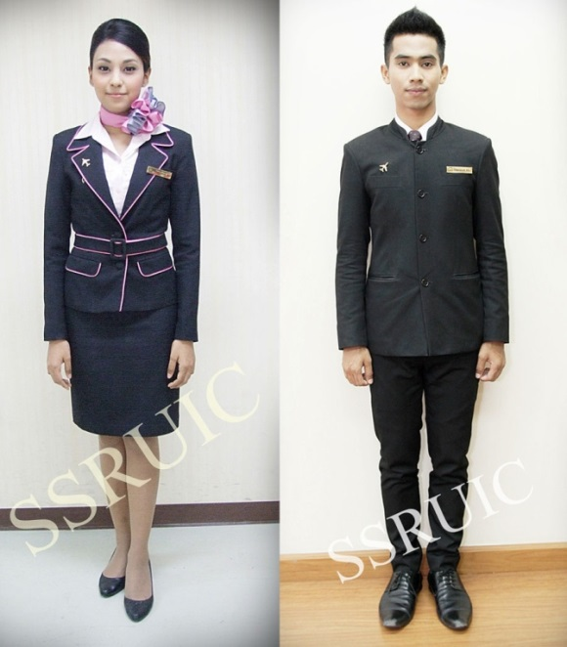

Jacket
- Be worn during internship at all time and be button up to the top line.
- Be worn ONLY College’s design in black color.*
*(any change in design to suit with the host uniform, students should ask for permission from college committee)
- The College’s name badge will be attached on the front left pocket at all times and the wing is attached above the name badge.
- Dry clean only and Be well pressed.
- Follow the washing and ironing instruction to maintain the color and neatness.
Belt
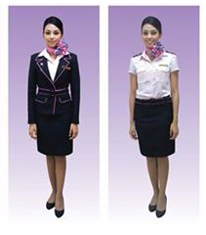
- The College/University belt must be worn at all time with student uniform.

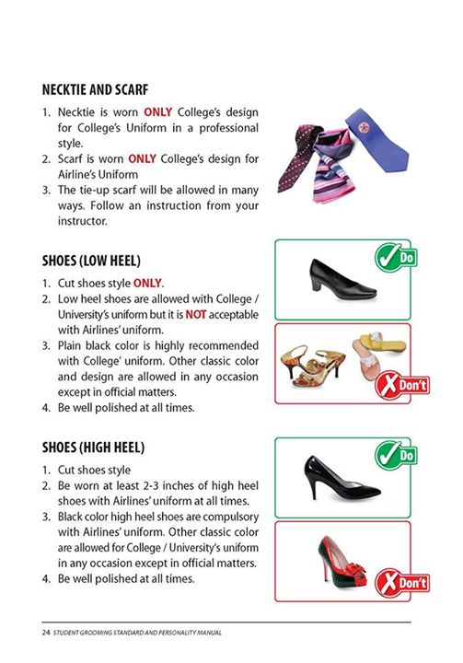

Neck Tie & Scarf
- Necktie is worn ONLY College’s design for College’s Uniform in a professional style.
- Scarf is worn ONLY College’s design for Airline’s Uniform.
- The tie-up scarf will be allowed in many ways. Follow an instruction from your instructor.

Trousers
- Jeans or fashionable design is NOT allowed.
- Slack style is recommended NOT a slim fitted body.
- Black color only and be well pressed.
- The college/University belt must be worn at all time with student uniform.
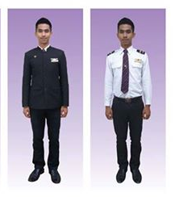

SHOES
- Cut shoes style ONLY, Sandal and Sport shoes are NOT allowed with Uniform.
- Plain black color is a compulsory with Airline Uniform.
- Wear ONLY high heel shoe at least 2 inches’ height at all time.
- Be well polished at all time.

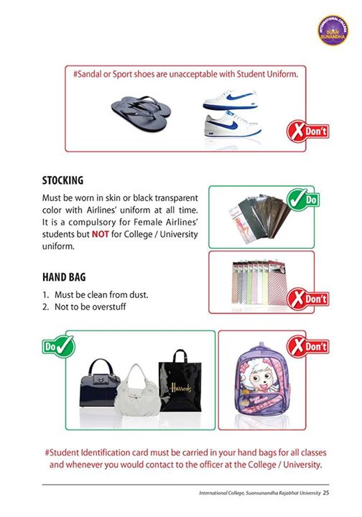

Hair

The following are permitted:
- Hair clip attached with ribbon, classic color and design, black color is preferable.
- French Braiding, French Twist, French Roll are allowed.
- Hair can be dyed tinted with a classic color, but if the color is unsuitable, the College’s committee has the right to ask the students to revert to their original hair color.
- Airline students are NOT ALLOWED to tie up their hair as a “pony tail” Normal type of CLASSIC BUN with a ribbon net is highly recommended.
- French Pleat is also allowed but the tail must be neatly tucked under the hair.
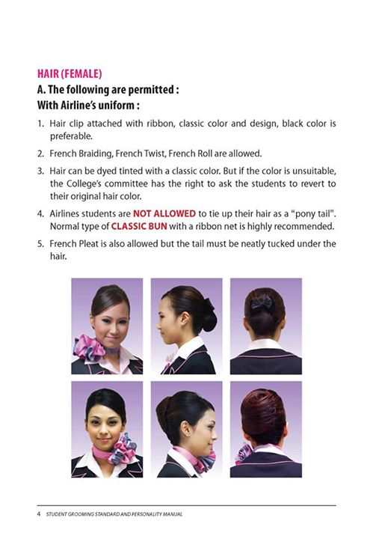

The following are NOT permitted:
- Hair must never fall across the face, styling your hair with gel, mousses etc.
- Any form of sparkling and glittering dust /hair spray e.g. Gold and silver are strictly not allowed.
- Clip that have “caricature”: cartoon characters, fashionable, color hairpin is not allowed.

**However small fashionable hair clips with diamond or crystal studded is allowed maximum two only: each side of hair or one side of the hair
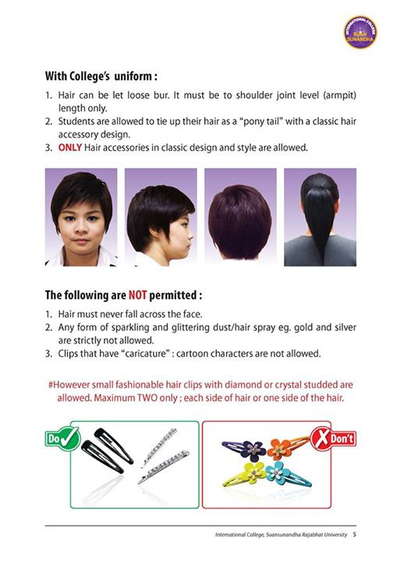

STOCKING
- Must be worn in skin or black transparent color with Airlines’ uniform at all time.

Handbag
- Must be clean from dust and Must not be over stuffed.
- Black color or Navy Blue color are highly recommended.
- Non – Professional hang bag, any cartoon character style is NOT allowed.

**Student identification card / Airport Authority card/ any official Airline pass card must be carried at all time

Other Guideline
- Picking or scratching of ears and nose should be avoided when in public.
- Do not eat or drink in public area while you are not allowed to take a break.
- Do not eat or drink in the hall way on your duty where passenger can notice.
- Pointing with a finger is not allowed, use an open palm and point with all fingers of the hand.
- Do not use your lips to point, pouting towards something or someone is not allowed.
- When in hurry, try not to run. You can still look good when waling quickly.

Chapter 3
Student internship practices and guidelines

The student’s internship is under the direction of an identified supervisor appointed to supervise within Thailand or overseas. During the internship, it is necessary to comply with the rules and regulations of SSRU and the workplace to assure a smooth internship which greatly affects the evaluation and achievement of the student’s internship as well as to the reputation of Suan Sunandha Rajabhat University.
Practices
Student duties
1. Write and submit a weekly journal to supervisor or instructor through Moodle System. and/or E-mail for acknowledgement and recommendation.
2. Report any problems that arise or sickness to SSRUCHM advisors and workplace supervisor.
Student’s responsibilities
- The student must comply with good personality and university standard grooming at all times from the residence to workplace and/or in the public areas.
- The student must be at the workplace before the assigned schedule work time.
- The student must not use the mobile phone while on the duty and in the public areas.
- The student must not request a preferred working shift or working team with the host.
- The student has to submit the internship final report with a CD-ROM file written in PDF Form within two (2) weeks after completion of the internship in Hard copy form (Appendix B). The report may include additional document(s) as an appendix.

Guidelines for students during the internship
Work place practices
  - Strictly follow the rules and regulations of the host enterprise.
  - Regularly attend and complete each task with full intention and attention.
  - Comply to the restrictions for the organization’s confidentiality.
  - Take advice and accept correction from instructors and inspectors with respect.

Rules & Regulations During internship
- Dress code and grooming:
Dress in university’s uniform or SSRUCHM’s airline uniform or as instructed by the host organization during the internship with the best practices of ‘Good Personality and Grooming’ at all times.
- ‘MUST DO’ Practices:
  - Working hours
    - 8 hours per day.
    - Students have no right to ask for salary, wage, or any payment from the host in the case of their working hours are within the regular time as permitted in 2.1.1.
  - If requested by the host to work overtime, consent letter from the student is necessary.
  - Arrive to work and leave at the time as mentioned in the rules and regulations of the host.
  - Attend at least 80% of work time assigned including orientation and final wrap-up meeting at the university.
- Good Practices (DO)
  - Always stay in the workplace vicinity, do not leave the place without approval from the supervisor.
  - Be humble with polite manners, and strictly follow the instruction of supervisor and/or instructor.
  - Be an energetic intern student.
  - Maintain a positive attitude in the workplace at all times.
- Prohibited practices (DON’T)
  - Do Not Request for your preferred working shift and or working team with the host.
  - Do Not Violate the workplace rules and regulations.
  - Do Not Participate or cause or lead to an argument or fighting.
  - Do Not Gamble.
  - Do Not Cause any damage to public or personal property.
  - Do Not Consume alcohol at work or take drugs.
  - Do Not Commit an affair or adultery/sexual harassment.
  - Do Not Steal or violate any laws.
  - Do Not Use host’s computer for your personal purpose.
  - Do Not Use mobile phone in the public area during working hours.
  - Do Not Ask the ‘Airline staff’ to buy duty free items.
  - Do Not cheating in any circumstance for example ask friend to sign your name for you.
  - Do Not absent from work or take leave without permission from host or from Advisor.
  - Do Not participate with any of illegal or against the rules or violate the laws.

- Leave (Leave Form in Appendix C):
  - Sick leave
    - Sick leave Less than 3 days, the student must submit a leave form to internship supervisor and report to SSRUCHM supervisor on the first day returning to work (or to authority).
    - Sick leave More than 3 days, the student must submit a leave form with a medical certificate to internship supervisor, and report to SSRUCHM supervisor.
  - Other leave
    - Submit a leave form to internship supervisor and report to SSRUCHM supervisor for approval before the leave.
- Penalty
  - Parole
For those violations with intention or recurrent cases with a previous warnings.
  - Termination
For a recurrent cases with a prior paroles.

- Penalty appointment
During internship, the internship supervisor and the SSRUCHM supervisors are in charge of appointing the penalty:
  - Warnings
    - Verbal Warning by internship supervisor.
    - Written Warning by internship supervisor once verbal warning exceeded.
    - Termination letter by internship supervisor once written warning exceeded.
  - Internship supervisor and SSRUCHM supervisor report to the Dean of International College, Suan Sunandha University by phone, email or a letter.
  - As the case informed, the commences of the preliminary fact finding and report to the program board to appoint the penalty as in Section 6. (Penalty).
  - Student in parole as in Section 6 must report to the SSRUCHM once violations happened for further proceeding of the university regulations.

- Appeal against penalty
If the student subjected to penalty considers it as partiality or non-justified penalty, the student needs to appeal to the Dean of International College by written form within 15 days from acknowledgement.
- Student’s right (Internship terminations)
Students have the right to terminate the internship if necessary, but under the consideration of SSRUCHM Committee board in a particular case.
Chapter 4
Roles of internship host and internship supervisor

For the internship of the students in B.A. degree in Airline Business program to a different host, the host internship supervisor and the SSRUCHM supervisor (program teacher) are definitely important to the effectiveness and efficiency of the internship.
The roles are as follow;
  - Roles of internship host enterprise
  - Internship evaluation.
The supervisors at host enterprise and SSRUCHM have a role in evaluating the student’s internship. The student’s scores are from;
        - The performance through given assignments.
        - Adaptability to the working environment.
        - Learning skills developed by the student.
        - Personality and grooming.
  - Students’ behavior complies with the host’s rules and regulations.
Host and supervisor are authorized and assigned to control the student’s behavior to comply with the rules and regulations of the host. If violated, host and internship supervisor can give a warning and appropriate penalty (Chapter 3, Section 6).
  - Working skill training.
Host and internship supervisor play an important role in the internship student’s work and learning development through his/her management skills and experience. The supervisor is considered to be a teacher as well.
  - Role of supervisors
  - Evaluate the internship
Supervisor/Inspector has roles to monitor and evaluate the student by visiting the student at each internship place to evaluate work performance, self-development, adaptability and learning capacity using the Rubric Form in Appendix F. In addition, the supervisor/inspector is assigned to evaluate internship reports submitted by the student which express the application of student’s knowledge to actual practice.
  - Consultancy
When visiting the student’s internship, the SSRUCHM supervisor has a role as a consultant to various problems found at work, then discuss the problems with the host to find possible solutions. If receiving a report of student violation, the SSRUCHM supervisor should find the facts and report to the Dean of International College in written form.
  - Grading
SSRUCHM supervisor has to evaluate students’ performance by using the host supervisors’ report and students’ Internship reports which express the application of students’ knowledge to actual practice. (Appendix E)
Chapter 5
Monitoring and evaluation
Evaluation methods
When commencing internship, the program sends out the supervisor/inspector twice; at the beginning and at the end of the internship. Throughout the required duration of the internship program, students should have good conduct and cause no difficulties to the host and the university.
Criteria and evaluation of the internship
After finishing the internship, One(1) Hard copy of internship report is obliged to be submitted to the SSRUCHM supervisor/inspector, One (1) file written in PDF form, and provided a presentation/exhibition. The SSRUCHM supervisor/inspector compiles all scores for evaluating the student’s grading. The Grading Criteria are as follows.
The evaluation system is:
- Attendance & Participation 10%
- Host’s Evaluation in Work Performance 20%
- Supervisor/Inspector’s Evaluation 20%
- Internship Final Report 20%
- Internship Presentation 20%
- English usage 10 %
Total 100%

Remarks:

- Report has to be handed to your program supervisor by……………at………………
- Penalty for late report will be a 1% deduction of points per day.
- Internship Presentation Seminar/Exhibition in…………………(To be advised)

The Grade Report Criteria
Student' score % | Grade | Result/Remark
86.00-100.00 | A | 4.00
82.00-85.00 | A⁻ | 3.75
78.00-81.00 | B⁺ | 3.50
74.00-77.00 | B | 3.00
70.00-73.00 | B⁻ | 2.75
66.00-69.00 | C⁺ | 2.50
62.00-65.00 | C | 2.00
58.00-61.00 | C⁻ | 1.75
54.00-57.00 | D⁺ | 1.50
50.00-53.00 | D | 1.00
46.00-49.00 | D⁻ | 0.75
0.00-45.00 | F | 0
- | I | Incomplete
- | W | Withdraw

Appendix

Appendix A: แบบฟอร์มการขอออกหนังสือการฝึกประสบการณ์วิชาชีพ | รูปนักศึกษา
หลักสูตรศิลปศาสตรบัณฑิต สาขาวิชาธุรกิจการบินรุ่น 60-64 | 1 นิ้ว
วิทยาลัยการจัดการอุตสาหกรรมบริการ มหาวิทยาลัยราชภัฏสวนสุนันทา


วันที่____ เดือน____________ พ.ศ. _______

เรื่อง ขอความอนุเคราะห์ออกหนังสือการฝึกประสบการณ์วิชาชีพ เรียนคณบดีวิทยาลัยการจัดการอุตสาหกรรมบริการ

เนื่องด้วยข้าพเจ้า (นาย/นางสาว) ________________________________รหัสนักศึกษา________________
ชั้นปีที่ ______ สาขาวิชา______________ กลุ่ม_______ โทรศัพท์_______________ E-Mail _________________
มีความประสงค์ขอให้ฝ่ายธุรการออกหนังสือฝึกประสบการณ์วิชาชีพ เรียน

ชื่อหน่วยงาน (กรุณากรอกชื่อบริษัท ให้ถูกต้อง)____________________________________________ เพื่อออกหนังสือ
( ) IAC4534 : การเตรียมฝึกประสบการณ์วิชาชีพในสาขาธุรกิจการบิน
(Preparation for Internship in Airline Business จำนวน 3 (อย่างน้อย 135 ชั่วโมง) หน่วยกิต
( ) ABI 4537 : การฝึกประสบการณ์วิชาชีพในสาขาธุรกิจการบิน
(Internship in Airline Business) จำนวน 7 (อย่างน้อย315 ชั่วโมง)

ที่อยู่(หน่วยงาน) เลขที่________ อาคาร___________ ชั้น____ ถนน _____________ ตำบล/แขวง____________

อำเภอ_______________________ จังหวัด___________________________ รหัสไปรษณีย์_________________
โทรศัพท์___________________________ โทรสาร ______________________________
ตั้งแต่วันที่_______-เดือน___________ พ.ศ. _________ |  |  |  |  | ถึงวันที่______ เดือน_____________ พ.ศ. _________
ฝึกประสบการณ์วิชาชีพทุกวัน_______________ ถึง__________________ วันละ_____________ ชั่วโมง
ผลการเรียนรวมภาคเรียนที่..................... |  |  | ปีการศึกษา ................................. |  | คะแนนเฉลี่ย ................................
 |  |  |  |  | ขอแสดงความนับถือ
 |  |  | ชื่อ– นามสกุล______________________________
TOEIC Score**
Year 1 | 1st ____ | 2nd____ | 3rd ____
Year 2 | 1st ____ | 2nd____ | 3rd ____
Year 3 | 1st ____ | 2nd____ | 3rd ____
Year 4 | 1st ____ | 2nd____ | 3rd ____

**เกณฑ์คะแนน TOEIC ที่นักศึกษาต้องผ่านในแต่ละภาคการ อยู่ด้านหลัง

ขั้นตอนการดำเนินงาน
อาจารย์ที่ปรึกษา |  | หัวหน้าสาขาวิชาธุรกิจการบิน |  | เจ้าหน้าที่ฝ่ายวิชาการ |  | คณบดีวิทยาลัยการจัดการ
 |  |  |  |  |  | อุตสาหกรรมบริการ
อนุญาต |  | อนุญาต |  | ❒ มีสภาพเป็นนักศึกษา |  | ❒ อนุมัติ
❒ ไม่อนุญาต เนื่องจาก |  | ❒ ไม่อนุญาต | เนื่องจาก | ❒ ไม่มีสภาพเป็นนักศึกษา |  | ❒ ไม่อนุมัติ
............................................... |  | ...................................................... |  | เนื่องจาก ................................... |  | เนื่องจาก ..................................
ลงนาม .................................. |  | ลงนาม.................................. |  | ลงนาม .................................. |  | ลงนาม ..................................
(................................................... | ) | (................................................... | ) | (................................................... | ) | (................................................... | )

หมายเหตุ: เงื่อนไขกรณีนักศึกษาคะแนนTOEIC ไม่ถึง 480 คะแนน ตามเกณฑ์ให้ฝึก ประสบการณ์วิชาชีพ

- กรณีนักศึกษาที่คะแนนTOEIC ไม่ถึง 480 วิทยาลัยอนุญาตให้ฝึกงานเฉพาะ Pre-Internship เป็นระยะเวลา 2 เดือน หลังจากนั้นต้องยื่นผลคะแนน TOEIC480 ใหม่ ถึงจะอนุญาตให้ฝึกงาน Internship ระยะเวลา 4 เดือน

- การยื่นฝึกงานPre-Internship ระยะเวลา 2 เดือนอนุญาตให้ยื่นคะแนนTOEIC ที่คะแนน 420 ขึ้นไป

 |  | นักศึกษารับทราบ
 |  | ลงลายมือชื่อ
 |  | ……………………………………………………………
 |  | (............................................................... |  | )
**คะแนน TOEIC ที่นักศึกษาต้องผ่านเกณฑ์ใ แต่ละภาคการศึกษา ดังนี้
ชั้นปี/ ภาคการศึกษา | ภาคเรียนที่ 1 | ภาคเรียนที่ 2 |  | ภาคเรียนที่ 3
ชั้นปีที่ 1 | 300 | 335 |  | 355
ชั้นปีที่ 2 | 375 | 410 |  | 430
ชั้นปีที่ 3 | 450 | 485 |  | 505
ชั้นปีที่ 4 | 525 | 565 |  | 600

Appendix B
ABI 4537: Internship in Airline Business
Details about Internship Report
Components of the Internship Report
Weighted Grading %

Front cover: Print on hard cover paper (Theme Color will be set for each year by Airline Business Program)

Front inner cover: Blank regular A4 paper, and next page print on regular A4 paper, printed identically to the cover

Table of contents and Table of figures (5%)

Summary (5%)

Chapters:

Chapter 1: Introduction (20%)

Chapter 2: All about Experiences (20%)
Chapter 3: Research (20%)
Chapter 4: Recommendations (20%)
- References (5%)
- Appendices (5%)
- Back inner cover: Blank regular A4 paper
- Back cover: use hard cover paper
- Font: use the ‘Times New Roman’ Font through the report
- Chapter: 20 pts Bold
- Chapter Topic (Line below the chapter): 18 pts Bold
- Topic (Subject to the left of page): 16 pts Bold
- Contents: 14 pts, write as academic writing format
- Page Layout (Paragraph): use 1.5 lines for line space
- Each Picture/Table: 11pts, lower center of the picture, use this phrase;
Figure (Number) …Explaining about picture/table…
- Page number: Put only the page number on Top-Right corner, font ‘Times New Roman’ 12 pts

Internship Report (Times New Roman28pts Bold)

Name of Host…….
(Airline or Company relate to airline business)
(Times New Roman22pts)

By
Name of Student……..
Student ID……….
(Times New Roman 22pts)

A part of requirements for course
ABI 4537: Internship in Airline Business
(Times New Roman 18pts)

Semester ……., Academic Year ………
College of Hospitality Industry Management,
Suan Sunandha Rajabhat University
Bangkok, Thailand. (Times New Roman 14pts)

--Blank page--

Table of Contents (20pts Bold)

I. Preface Page #

II. Chapter 1 Introduction

- Company Overview Page #
- Department Overview Page #
III. Chapter 2 All about Experiences
- Internship student responsibilities Page #
- Achievement experiences Page #
IV. Chapter 3 Research
- Research Page #
V. Chapter 4 Recommendations

A. Attitude towards this career after this internship Page #
B. Define problem that happened Page #
C. Recommendation towards Department Page #
D. Recommendation towards yourself Page #
- Explain any Airline Business subject that you
have learnt and can apply during your internship Page #
VI. References Page #

VII. Appendix Page #

Table of Figures (20pts Bold)

1. Figure 1 Page #
2. Figure 2 Page #
…

Preface (20pts Bold)
(1 Blank space)
Explain the reason that why you select to conduct your internship with this host and explain about internship working place, department, job responsibilities and outcome expectation moreover you can say thank you to your host and the relevant person in this part (at least 1 page).

Chapter 1 (20pts Bold)
Introduction (18pts Bold)
(1 Blank space)
Details in Chapter 1
In Chapter 1, write the Introduction about the background of the Internship cover in these details; (in Essay form 1,000 words; introduction, contents, conclusion) (14pts)
- Company Overview
- Vision
- Mission
- Organizational Structure
- Brief history
- Department Overview
- Department Structure
- Department responsibilities
Format
Topic (16pts Bold)
Contents…….. (14pts)

Chapter 2 (20pts Bold)
All about Experiences (18pts Bold)
(1 Blank space)
Details in Chapter 2
In Chapter 2, write about the department overview, supervisor, duration of internship, Intern student responsibilities, and achievement experiences follow these details; (in Essay form 2,000 words; introduction, contents, conclusion) (14pts).
- Intern student’s responsibility
- Describe about student’s job descriptions in the department.
- Achievement Experience
- Any successful Experiences.
- Any Experience that can enhance your ability in the future.
- Describe whichever good or bad, threats, and hot you solve the problem (if any).
Format
Topic (16pts Bold)
Contents…….. (14pts)

Chapter 3 (20pts Bold)
Independent Study (18pts Bold)
(1 Blank space)
Details in chapter 3

Independent Study Topic: Customer service related
- Abstract
- 3.1 Introduction
- 3.2 Literature review
- 3.3 Methodology
- 3.4 Result
- 3.5 Conclusion
- Reference in Independent Study

Format
Topic (16pts Bold)
Contents (14pts)

Chapter 4 (20pts Bold)
Recommendations (18pts Bold)
(1 Blank space)
Details in chapter 4
In Chapter 4, describe about problem that happens during your internship and the recommendations to solve problems as follow these details; (in Essay form 500 words; introduction, contents, conclusion) (14pts)
- Attitude towards this career after this internship
- Define problem that happened
- Recommendation towards Department
- Recommendation towards yourself
- Explain any Airline Business subject that you have learnt and can apply during your internship
Format
Topic (16pts Bold)
Contents…….. (14pts)

References (20pts Bold)
(1 Blank space)
Referencing information can be daunting for students who do not understand the principles.
There are numerous ways to reference. Different institutions, departments or lecturers may require different styles. Check with the latest APA (American Psychological Association) style is most frequently used within the social sciences, in order to refer various sources.
Bad referencing is a common way for students to lose marks in assignments, it is worth both time and effort to learn how to reference correctly.
At the end of your essay, place a list of the references you have cited in the text. Arrange this in alphabetical order of authors' surnames, and then chronologically (earliest publication date first) for each author where more than one work by that author is cited.
Why Do We Cite and Reference?
When writing final report for your internship graduation, you need to highlight your use of other author's ideas and words so that you:
· give the original author credit for their own ideas and work
· enable the reader to follow up on the original work if they wish to
· enable the reader to see how dated the information might be
· prove to your tutors/lecturers that you have read around the subject
· avoid plagiarism
What is Plagiarism?
· Presenting another's ideas as if they are your own – either directly or indirectly
· Copying or pasting text and images without saying where they came from
· Not showing when a quote is a quote
· Summarizing information without showing the original source
· Changing a few words in a section of text without acknowledging the original author

References (20pts Bold)
(1 Blank space)
Books
Author, A. A. (year). Title of work. Location: Publisher.
Example:
International Air Transportation (IATA). (2012). Introduction to the airline industry course textbook. Montreal, Canada: IATA Publishing House.
Yamane, T. (1967). Statistics: An Introductory Analysis. (2nd ed). New York: Harper and Row.
Online
Author, A. A. (year). Title of work. Retrieved ....(date).......from http://www.xxxxxxxxxxx
Example :
Burton, R. (1832). The anatomy of melancholy. Retrieved January 12, 2015 from http://etext.library.adelaide.edu.au/b/burton/robert/ melancholy/
Smith, A. J. (2001). Child development. In B. Strickland (Ed.), The encyclopedia of psychology. Retrieved October 25, 2008, from http://www.gale.cengage.com/
Wong, A. W. (2009). Pregnancy postpartum infections. Retrieved December 8, 2009, from http://emedicine.medscape.com/article/796892-overview

Appendix (20pts Bold)
(1 Blank space)

Details of appendix
Present the sample of the documents or outcomes from the Internship or any item as part of the contents as follows:
- Letter
The letter of recommendation or complimentary from the workplace with host signature/stamp, which in the letter needs to state the Total number of Student Practicum hours (at least 315 Hours).
- Log of Practicum: Weekly report (Appendix D):
  - Describe scope of duty where the student interned, i.e., department/section, describe the duties and responsibilities assigned. Print out the one that you uploaded to Moodle.
  - Students Daily attendance record, Weekly Work Report.
- Original Training Record, Inspector Record.
- Brochures, Map of the site.
- Related documents to the job assigned.
- Photograph, Students’ Photographs, and the workplace with the description.
- Other suggestions.

Appendix C
Internship Student Leave Form
Date……./…..../….…
เรียน อาจารย์นิเทศก์
Dear Inspector
ชื่อ/ Name……………………………………รหัสประจำตัว / Student ID…………………………..
สาขาวิชา / Program…………………………..……มีความประสงค์ขอลาหยุด /I would like to apply my leave from date…..……to………..รวม.........วัน / Day(s)
ระบุความจำเป็นที่ต้องหยุด / Reason………………………..……………………………………………
ที่อยู่ที่สามารถติดต่อได้ระหว่างที่ลาหยุด / During my leave I shall be at
……………………………………………………………..…… โทร /Tel………………………………
ข้าพเจ้าได้แนบเอกสารต่อไปนี้เพื่อเป็นหลักฐาน / The following document(s) is/are attached as my evidence.
ใบรับรองแพทย์ / Medical certification
เอกสารอื่นๆ โปรดระบุ / Other Document Please Indicate………...…….……………

ลายมือชื่อนักศึกษา / Student’s signature…..……………………………………

ความเห็นอาจารย์นิเทศก์ / Inspector’s Comment
อนุมัติ / Approved ไม่อนุมัติ / Disapproved because…………………..……………………………………………
ลงนาม / Signature…………………………………………………………..…..Date……../…..…/……..

ผู้อำนวยการวิทยาลัยนานาชาติ / Director of International College
อนุมัติ / Approved
ไม่อนุมัติ / Disapproved, because…………………………………………………………………….

ลงนาม / Signature………………………………………………………………Date……../……../……...

Appendix D
Forms
- Student Daily Attendance Record Form
This form is for recording student daily time In/Out during the Internship.

- Student activities Weekly Record Form
This form is for monthly recording student activities during the Internship.

- Assessment Rubric Form for supervisor
This form is for Practicum supervisor to evaluate the performance of student.

 | Student Daily Attendance Record
 | Student Name: ________________________________________________
 | Student ID: ___________________________________________________
 | Name of Host : ________________________________________________
 | Duration (Month): _____________________________________________
 | Date | Time |  | Department | Activities & Work Assignment | Host Supervisor's Signature
 | Date | Time In | Time Out | Department | Activities & Work Assignment | Host Supervisor's Signature
1
2
3
4
5
6
7
8
9
10
11
12
13
14
15

 | Student Daily Attendance Record
 | Student Name: _________________________________________________
 | Student ID: __________________________________________________
 | Name of Host : _____________________________________________________
 | Duration (Month): _________________________________________________
 | Date | Time |  | Department | Activities & Work Assignment | Host Supervisor's Signature
 | Date | Time In | Time Out | Department | Activities & Work Assignment | Host Supervisor's Signature
16
17
18
19
20
21
22
23
24
25
26
27
28
29
30

Student Weekly Record
Student Name: ___________________________________________________
Student ID: ____________________________________________________
Name of Host : ___________________________________________________
Duration (Month): ________________________________________________

Activities and Work Assignments
........................................................................................................................................
........................................................................................................................................
........................................................................................................................................
........................................................................................................................................
Benefits / Experiences
........................................................................................................................................
........................................................................................................................................
........................................................................................................................................
........................................................................................................................................
Problems/Obstacles to the work
........................................................................................................................................
.......................................................................................................................................
.......................................................................................................................................
........................................................................................................................................
Student's Opinion
........................................................................................................................................
........................................................................................................................................
........................................................................................................................................
........................................................................................................................................
_________________________
Student's Signature
Supervisor's Opinion
........................................................................................................................................
........................................................................................................................................
........................................................................................................................................
_________________________
Supervisor's Signature
Student Evaluation Form (First Month Evaluation)

Student Name: ____________________________________________________
Student ID: _____________________________________________________
Name of Host : ____________________________________________________
Duration (Month): _________________________________________________

Performance | Poor  (Score1) | Fair  (Score 2) | Good  (Score 3) | Very Good  (Score 4)
Overall
Student’s Behavior
Behavior to other
Self-Behavior
Responsibility

Supervisor's Recommendation and Suggestion
........................................................................................................................................
........................................................................................................................................
........................................................................................................................................
........................................................................................................................................
........................................................................................................................................
........................................................................................................................................
........................................................................................................................................
........................................................................................................................................
_________________
Name of Supervisor
__________________
Supervisor's Signature
Date______________
Student Evaluation Form (Second Month Evaluation)

Student Name: ___________________________________________________
Student ID: ____________________________________________________
Name of Host : ___________________________________________________
Duration (Month): ________________________________________________

Performance | Poor  (Score1) | Fair  (Score 2) | Good  (Score 3) | Very Good  (Score 4)
Overall
Student’s Behavior
Behavior to other
Self-Behavior
Responsibility

Supervisor's Recommendation and Suggestion
........................................................................................................................................
........................................................................................................................................
........................................................................................................................................
........................................................................................................................................
........................................................................................................................................
........................................................................................................................................
........................................................................................................................................

__________________ Name of Supervisor __________________
Supervisor's Signature
Date______________
แบบประเมินนักศึกษาโดยผู้ควบคุมการฝึกปฏิบัติ (Host)
ชื่อ-สกุล_______________________________________________________รหัส______________________
(Name-Surname) (Student ID)
ชื่อสถานที่ฝึกงาน___________________________________ระยะเวลาฝึกงาน__________________________
(Name of Organization) (Duration)
หัวข้อการประเมิน |  | ควรปรับปรุง  Poor  (1) | พอใช้  Fair  (2) | ปานกลาง  Average  (3) | ดี  Good  (4) | ดีมาก  Superior  (5)
1.พฤติกรรมต่อสถาบันแหล่งฝึก Behavior to the Establishment
*ตรงต่อเวลา Attendance
*บุคลิกภาพและการวางตัว Personality
*การแต่งกาย Appearance
*การปฏิบัติตามระเบียบของหน่วยงาน Rules Respect
2.พฤติกรรมต่อผู้อื่น Behavior to others
*การมีมนุษยสัมพันธ์ Friendliness
*ความเป็นผู้นำ Leadership
*มารยาทในการปฏิบัติงาน Courtesy
3.พฤติกรรมต่อตนเอง Self Behavior
*ความซื่อสัตย์สุจริต Honest
*ความตั้งใจและความกระตือรือร้น Attitude
*ความสนใจในการแสวงหาความรู้เพิ่มเติม Learning Enthusiasm
*ความคิดริเริ่มสร้างสรรค์ Initiative
*ความสามารถในการแสดงความคิดเห็น Self Expression
4. ความรับผิดชอบต่องานที่ได้รับมอบหมาย Responsibility
*ความถูกต้องแม่นยำของผลงาน Job Accuracy
*ความรับผิดชอบและเป็นผู้ที่ไว้วางใจได้ Responsibility and Dependability
*การตอบสนองต่อการสั่งการ Response to Supervision
*คุณภาพของผลงาน Quality of Work
*ความรู้เกี่ยวกับวิชาชีพ Job Knowledge
*ความสนใจ อุตสาหะในการทำงาน Interest in Work
5.ทักษะการสื่อสาร Communication Skills
*การใช้ท่าทาง น้ำเสียงใบหน้า Body Language
*การสื่อสารด้วยวาจา Oral Language
รวม Total
ข้อเสนอแนะ / ความคิดเห็น (Opinions/Suggestions)

ลงชื่อผู้ควบคุมการฝึกงาน
(Supervisor’s Signature)
Appendix E
Rubric Assessment Criteria
Student Assessment Regulation
Level | Behavior to Establishment | Behavior to other | Self Behavior | Responsibility
Poor  (1) | - Often absent without good reason or frequently report for work late  - Very untidy and does not follow the rules | - Very distant  - Does not respect supervisor when he/she comments  - Discourteous, antagonistic | - Lacks of motivation  - Lacks of knowledge seeking | - Make frequent errors  - Poorly informed about work duties  - Does not meet minimum of quality requirement
Fair  (2) | - Lacks in attendance and for reporting for work on time  - Sometimes untidy and careless about personal appearance  - Lack in following the rules | - Approachable; friendly one known by other and be able to work with others  - Respect supervisor's advice but caress makes recurrent | - Average in creativity, self-expression and motivation | - Usually accurate makes only average number of mistakes  - Moderately informed and can answer most common questions
Good  (3) | - Usually present and on time, regular in attendance  - Generally neat and clean and follow the rules | - Warm, friendly and sociable Respect supervisor  - Criticisms and comments acceptable and be able to improve | - Very in creativity and industrious  - Goes ahead independently at times | - Require little exact and precise supervision  - Understand all phases of work
Very Good (4) | - Very prompt, volunteers for overtime when needed  - Always well groomed; good taste in dress | - Very sociable and outgoing  - Always very polite and willing to help | - Outstanding in creativity  - Self-starter-seeks work  - Always motivated | - Almost always accurate  - Has complete mastery of all phases of job  - Superior work production record

Rubric Assessment Criteria
เกณฑ์ประเมินการปฏิบัติตนของนักศึกษา
Student Assessment Regulation
ระดับ | พฤติกรรมต่อสถาบันแหล่งฝึก | พฤติกรรมต่อผู้อื่น | พฤติกรรมต่อตนเอง |  | ความรับผิดชอบต่องาน
ควรปรับปรุง (1) | - ขาดงานเละหรือมา  สายเป็นประจำโดยไม่มีเหตุผลเพียงพอ  - แต่งกายไม่สุภาพเรียบร้อยไม่ปฏิบัติตามกฎของสถาบันแหล่งฝึกเป็นประจำ | - วางตัวห่างเหินกับผู้อื่น  ไม่เคารพและยอมรับเมื่อมีการว่ากล่าวตักเตือน  - ประพฤติตนไม่สุภาพ  แสดงกิริยามารยาทอันไม่สมควร | - ขาดความตั้งใจและ  กระตือรือร้น  - ขาดความเอาใจใส่ในการ  แสวงหาความรู้ |  | - มักทำผิดพลาด  สม่ำเสมอ  - ขาดความรู้เรื่อง  วิชาชีพและหน้าที่ที่ต้องปฏิบัติ  - คุณภาพของงานไม่ได้  ตามมาตรฐาน
พอใช้ (2) | - ขาดงานและมาสาย  เป็นบางครั้ง  - หละหลวมเรื่องการแต่ง  กายเป็นบางครั้ง  - หละหลวมเรื่องการ  ปฏิบัติตามกฎของสถาบันแหล่งฝึก | - เข้าหาผู้อื่น สามารทำงาน  ร่วมกับผู้อื่นได้  - ยอมรับเมื่อมีการว่ากล่าวตักเตือน แต่ยังมีการทำผิดพลาดซ้ำบ้าง  - ประพฤติตนเป็นที่ยอมรับ  ได้ | - มีความตั้งใจและ  กระตือรือร้นในระดับทั่วไป  - มีความคิดริเริ่มสร้างสรรค์  บ้างและสามารถแสดงความคิดเห็นได้ |  | - ทำงานได้ถูกต้องเป็น  ส่วนใหญ่ แต่ยังมีผิดพลาดบ้าง  - มีความรู้เรื่องวิชาชีพ  และหน้าที่ของตนพอสมควร สามารถตอบคำถามทั่วไปได้  - คุณภาพของงานได้  มาตรฐานทั่วไป
ดี (3) | - เข้างานตรงเวลาและ  สม่ำเสมอ  - แต่งกายสะอาด สุภาพ  เรียบร้อย  - ปฏิบัติตนตามกฎระเบียบเป็นอย่างดี | - มีมนุษย์สัมพันธ์ดี เข้าสังคม  ง่าย  - เคารพผู้ควบคุมการฝึกงาน  และยอมรับคำกล่าวตักเตือนและมีการปรับปรุงตัว  - มีมารยาทดี ประพฤติตน  เหมาะสม | - มีความคิดริเริ่มสร้างสรรค์  และมีความขยันแสวงหาความรู้  - เป็นตัวของตัวเอง |  | - ทำงานได้เป็นอย่างดี  อาจยังต้องมีการแนะนำบ้าง  - มีความเข้าใจต่อหน้าที่  การงานดี  - คุณภาพของงานดี
ดีมาก (4) | - เข้างานก่อนเวลา และมี  - การทำงานล่วงเวลา  การแต่งกายสุภาพเรียบร้อย มีรสนิยมในการแต่งกาย | - มีมนุษย์สัมพันธ์ดีมาก เข้า  - สังคมและเปิดเผย  สุภาพเรียบร้อย เต็มใจช่วยเหลือผู้อื่น | - ฉลาดและมีความคิดริเริ่ม  - สร้างสรรค์  แสวงหาความรู้เพิ่มเติมอยู่ตลอดเวลา เป็นตัวของตัวเอง  - กระตือรือร้นตลอดเวลา |  | - ทำงานได้ถูกต้อง  แม่นยำเป็นส่วนใหญ่  - ปฏิบัติงานได้ตาม  วิชาชีพ  - คุณภาพของงานดีมาก

แบบประเมินการฝึกปฏิบัติงานโดยนักศึกษา
Place of Internship Assessment
ชื่อนักศึกษา (Name)...................................................................................รหัส (Code).....................................
สถานที่ฝึกปฏิบัติงาน (Place of Internship).........................................................................................................
ช่วงเวลาที่ฝึกปฏิบัติงาน ตั้งแต่ (From)..................................................ถึง (To)......................................................

ให้นักศึกษาประเมินหลังจากเสร็จสิ้นการฝึกปฏิบัติงาน ทั้งนี้ในการประเมินผล ให้นักศึกษาพิจารณาการฝึกปฏิบัติงานโดยให้ระดับคะแนนดังต่อไปนี้(Student must do this assessment after finish his/her internship period by giving score as level follows;)
ระดับ 1(Level 1) ไม่เคยมีการกำหนด ไม่มีการกระทำ ไม่ชัดเจน (Never / Unclearly)
ระดับ 2 (Level 2) มีการกระทำ หรือกำหนดบ้าง (Rarely/ Quite clear)
ระดับ 3(Level 3) ชัดเจน เปิดโอกาสให้มีการอภิปราย หรือ ซักถามบ้าง (Some/Clearly/Able to discuss)
ระดับ 4(Level 4) ชัดเจน ทั้งโดยวาจา เอกสาร และสามารถซักถามได้ หรือ เป็นจริง โดยปฏิบัติอย่างสม่ำเสมอ
(Often/Clearly/ Able to discuss/Truthfully)
การประเมินผู้รับผิดชอบการฝึกปฏิบัติงานของนักศึกษา (Supervisor Assessment) | ระดับ (Level)
1. มีการปฐมนิเทศโดยผู้รับผิดชอบ เกี่ยวกับการฝึกปฏิบัติงานวิชาชีพในประเด็นต่อไปนี้
(Orientations declared )
1.1 เป้าหมาย วัตถุประสงค์ และทักษะที่ควรได้รับเมื่อสิ้นสุดการฝึกปฏิบัติ
(Objectives, Goals and skills obtained when finish internship)
1.2 แนะนำองค์กร หรือสถานที่ฝึกงาน (Organization Introduction)
1.3 ระเบียบของสถานที่ฝึกงาน ขั้นตอน การวางตัวในการฝึกปฏิบัติ
(Internship Rules and Regulations)
1.4 ตารางการฝึกงาน (Practical Schedule)
2. การเปิดโอกาสให้ซักถาม พูดคุยพบปะ แลกเปลี่ยนและรับฟังความคิดเห็น
(Able to discuss)
3. ให้คำแนะนำและเป็นแบบอย่างที่ดีในการปฏิบัติงาน
(Provide good knowledge and demonstration)

2. นักศึกษาคิดว่า สถานที่ฝึกงานมีข้อดีอะไรบ้าง (What are the merits of organization?)

3. นักศึกษาคิดว่าอะไรบ้างคืออุปสรรคของการฝึกงาน (What are the difficulties of your internship?)

4. นักศึกษาคิดว่าการฝึกครั้งนี้บรรลุวัตถุประสงค์ของการฝึกปฏิบัติงานวิชาชีพระดับใด
(What are the aims levels of your internship?)

ใช้เกณฑ์ระดับ 1-4 โดย 1 น้อยที่สุด 4 มากที่สุด (1-Least, 4-Most)

เป้าหมายของนักศึกษาในการฝึกปฏิบัติงาน (Aims of Internship) | ระดับ (Level)

5. ความคิดเห็นเพิ่มเติม (Opinions)

ลงชื่อ (Student’s Signature) .................................................................นักศึกษา
(.................................................................)
วันที่ (Date).................................................

Appendix F
Details about Internship VDO Presentation Rubrics
Company / Dept.: _________________________________________________________________
Presentation Title :________________________________________________________________
Student Name(s): _________________________________________________________________
Skills | Excellent – 3 | Good – 2 | Fair – 1 | Poor – 0 | Score
Time usage | Student uses their time to work productively and efficiently. | Student uses most of their time to work productively and efficiently. | Student uses some of their time to work productively and efficiently. | Student does not use their time to work productively and efficiently.
VDO/Graphics | Presentation VDO and graphics are clear and relevant to topic. | Most presentation VDO and graphics are clear and relevant to topic. | Few of the presentation VDO and graphics are clear and relevant to topic. | Presentation VDO and graphics are not clear and relevant to topic.
Contents  - Department background | All of the contents are clearly visible, organized, and well placed. | Most of the contents are clearly visible, organized, and well placed. | Few of the contents are clearly visible, organized, and well placed. Maybe missing elements. | Missing most or all of the contents.
Idea Organizing | The project has an excellent design and layout, neat and easy to understand the content. | The project has a nice design and layout, neat and easy to understand the content. | The project needs improvement in design, layout, or neatness. | The project needs significant improvement in design, layout, and neatness.
Spelling, Grammar, Linguistic field | The project has excellent knowledge of spelling, grammar, linguistic field, and original content. | The project has 1-2 spelling, grammar, linguistic field errors with original content. | The project has 3-5 spelling, grammar, linguistic errors with original content. | The project has multiple spelling, grammar, linguistic field errors with original content.
Comment: ______________________________________________________________________
VDO Score: / 15
Vote Score: / 05
Total Score: / 20

