งาน 21 ข้อ เรื่อง Algebra (sec 2)
1.


2.
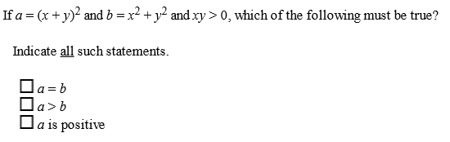

3.
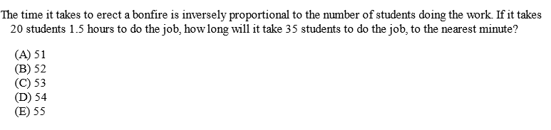

4.
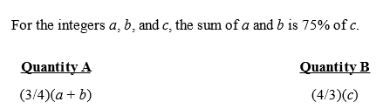

5.
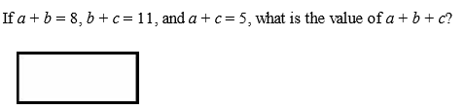

6.
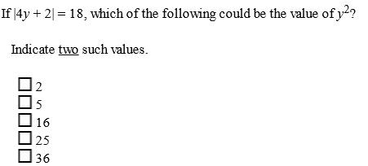

7. If $2{\left(x-1\right)}^{3}+3≤19,$then the value of x must be

(A) greater than or equal to 3
(B) less than or equal to 3
(C) greater than or equal to -3
(D) less than or equal to -3
(E) less than -3 or greater than 3

8.
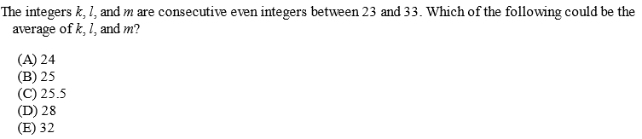

9.
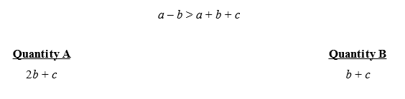

10.
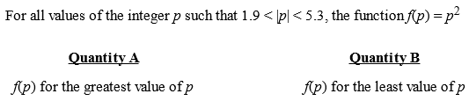

11.
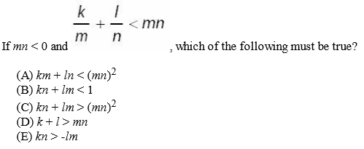

12.
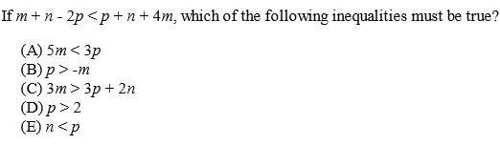

13.
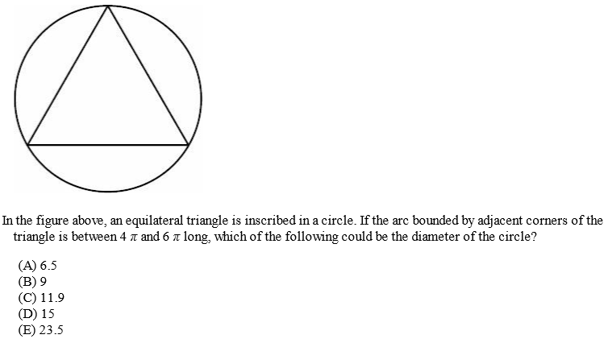

14.
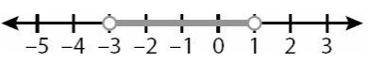
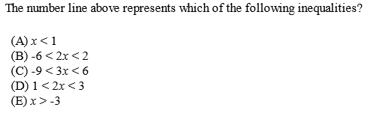

15.
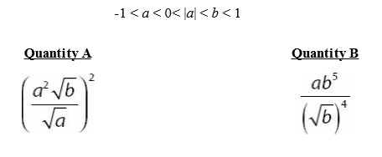

16.
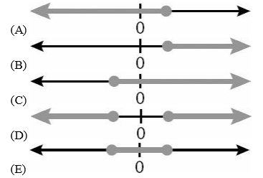

17.
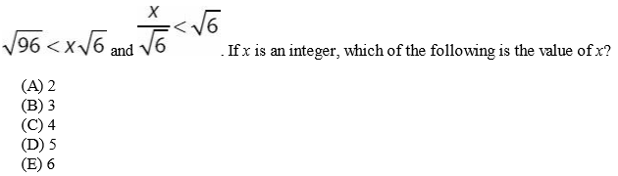

18.
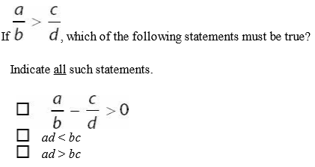

19.
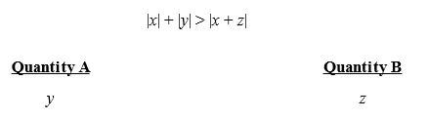

20.
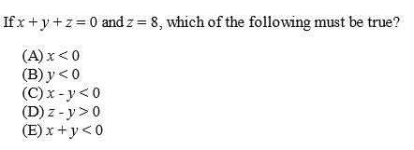

21.
